ABSTRACT

In today’s world security is very important. An integral part of security is authentication as based on a person’s identity he is authorized to certain privileges. There are many means for authentication, and signature is one among them. Since decades, signatures are considered as a means of authentication and ‘seal of approval’. An important advantage of the signature verification compared with others is its long tradition in many commercial fields such as e-business, which includes online banking transaction, electronic payments, access control and so on. In banks whenever a person wants to carry out ay financial transaction the signature is used to verify the identity of the person. To date signatures verification is done manually in banks where a person manually verifies the signature on the cheque with specimen signature. But this method is not accurate as naked eye cannot detect forgeries. Our proposed system deals with computerized signature verification in banking application. This is how signature verification system originated. Verification of signatures can be done on-line or off-line depending upon the application. Where the signature is captured and presented to the user in an image format. Signatures are verified based on parameters extracted from the signature using various techniques. The signature features, to be tested, are fed to the trained neural network to find whether the signature is genuine or a forged one.

INTRODUCTION

A signature may be termed a behavioural biometric, as it can modify depending on many essentials such as: frame of mind, exhaustion, etc. The exigent aspects of automated signature recognition and verification have been, for a long time, a true impetus for researchers. Research into signature verification has been energetically pursued for a number of years and is still being explored (especially in the off-line mode).

Utilization of the signature as an authentication method has already become tradition in the western civilization and is respected among the others. The signature is an accepted proof of identity of the person in a transaction taken on his or her behalf. Thus the users are more likely to approve this kind of computerized authentication method . Various classifiers, such as Support Vector Machines (SVMs) and Hidden Markov Models (HMMs), have also been successful in off-line signature verification; SVMs providing an overall enhanced outcome than the HMM-based approach .

SLIDES
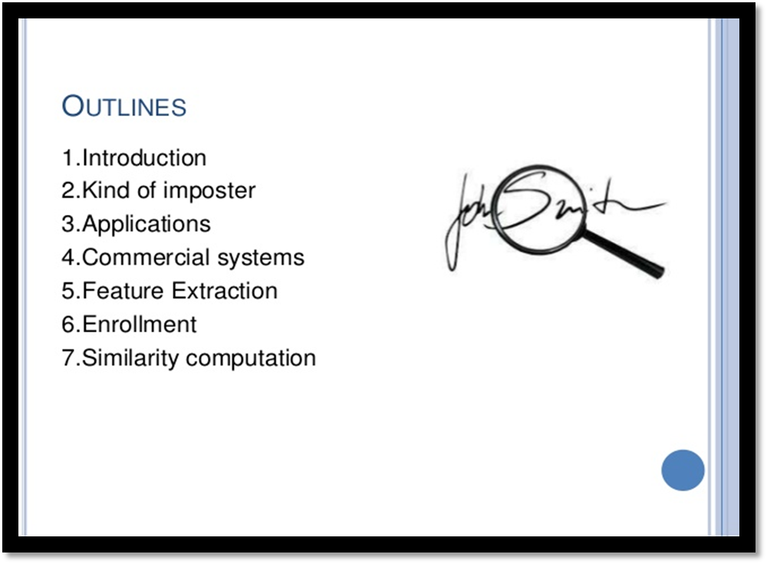
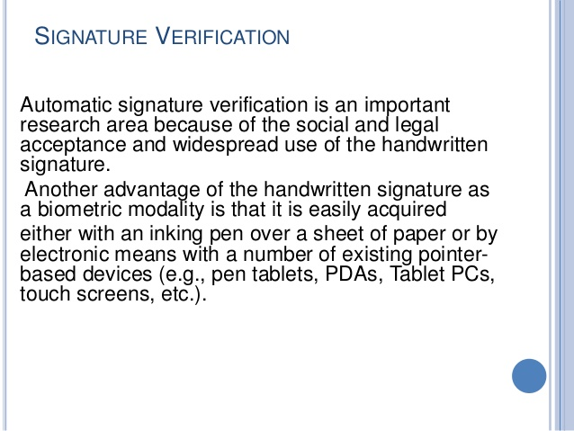

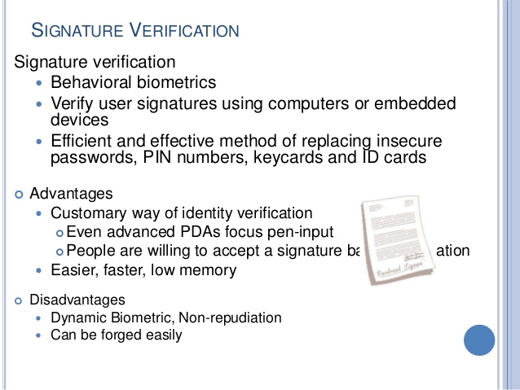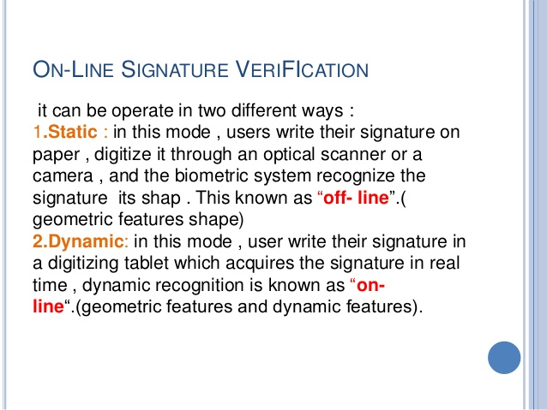

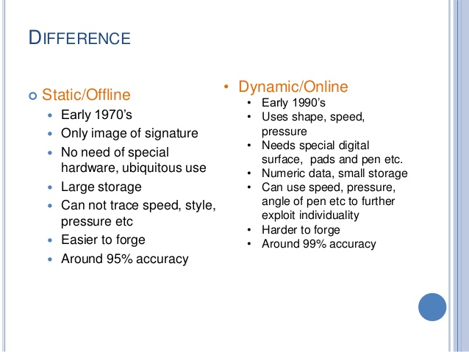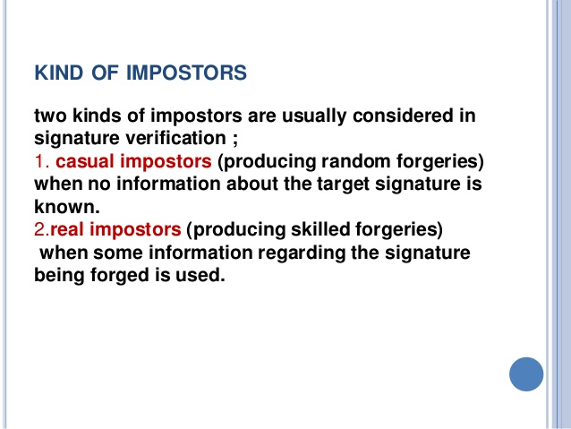

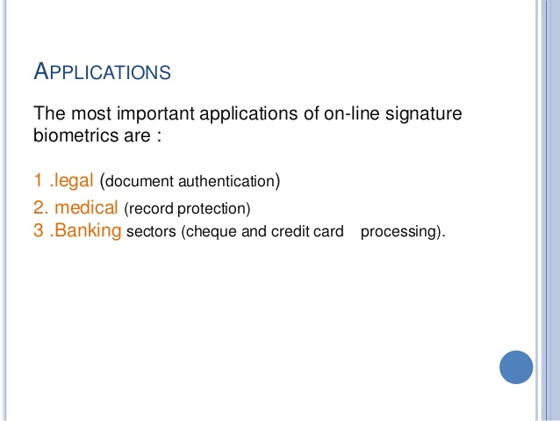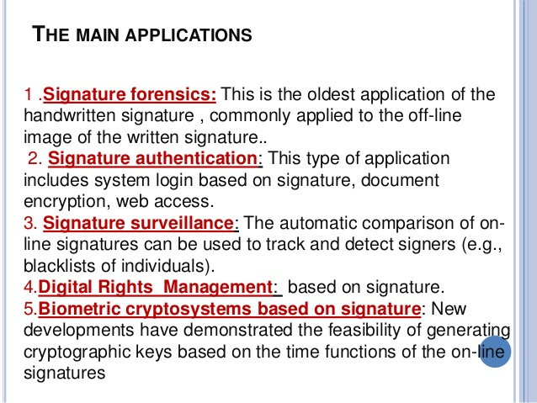

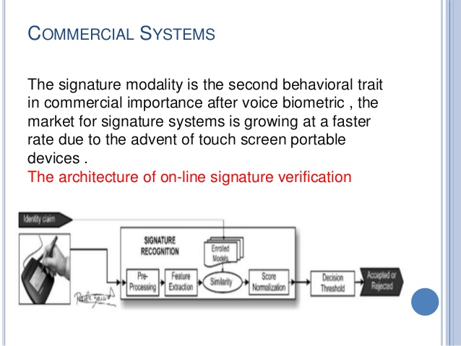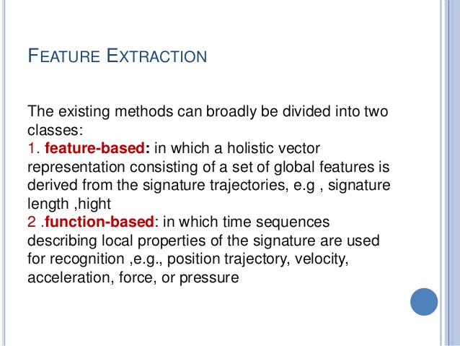

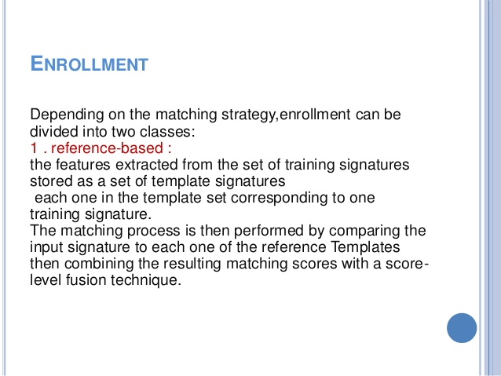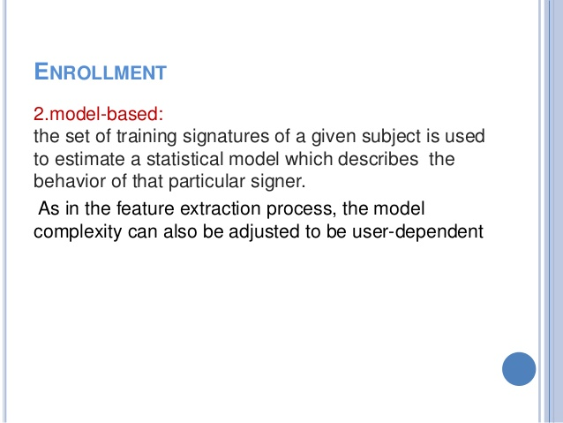

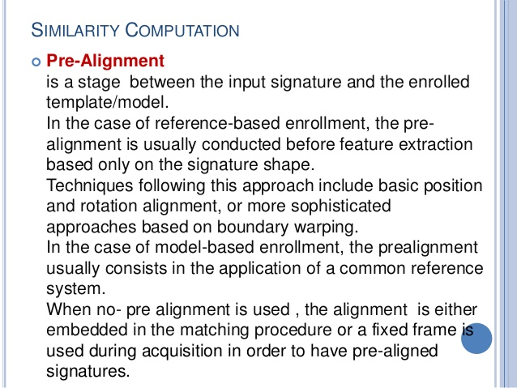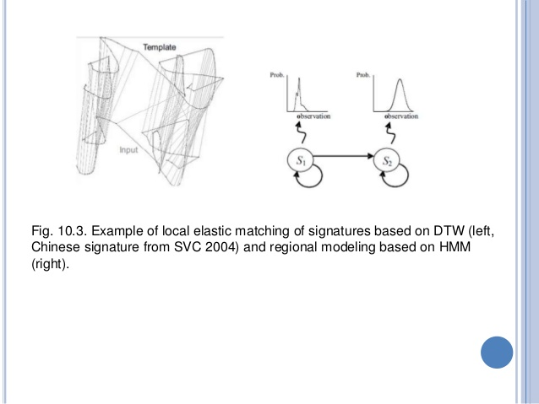

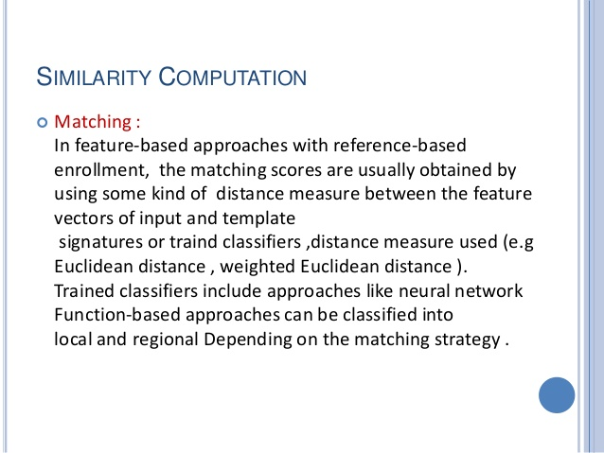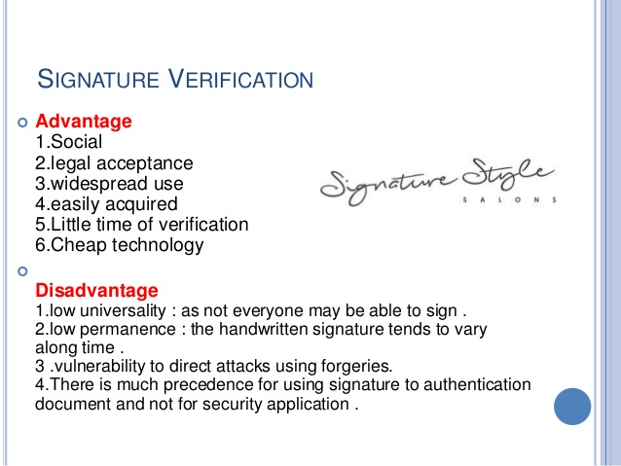

PROBLEM STATEMENT

Types of Forgeries

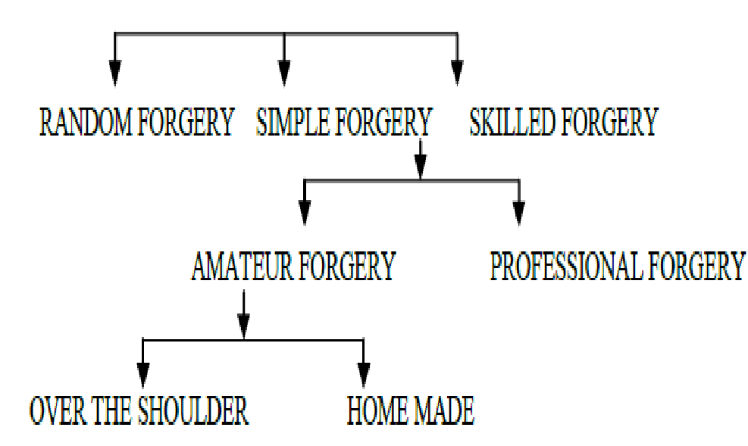
Fig1. Classification of Forgeries
•Random: these signatures are not based on any
Knowledge of the original signature
•Simple: these signatures are based on an assumption of how the signature looks like by knowing the name of the signer
•Skilled: an imitation of the original signature, which means that the person knows exactly how the original Signature looks like .
the distance between key strokes in the image, and the height/width of the signature. The combination of these features with the Modified Direction Feature (MDF) and the ratio feature showed promising results for the off-line signature verification problem. When being trained using 12 genuine specimens and 400 random forgeries taken from publicly available database, the Support Vector Machine (SVM) classifier obtained an average error rate (AER) of
17.25%. The false acceptance rate (FAR) for random forgeries was also kept as low as 0.08% . Alan McCabe et al, presents a method for verifying handwritten signatures by using ANN architecture. Various static (e.g., height, slant, etc.) and dynamic (e.g., velocity, pen tip pressure, etc.) Signature features are extracted and used to train the NN. Several Network topologies are tested and their accuracy is compared. The resulting system performs reasonably well with an overall error rate of 3.3% being reported for the best case .

OBJECTIVES

- To develop signature recognition & verification System by using artificial neural network.
- To verify an entered signature with the help of an Average signature, which is obtained from the set of, previously collected signatures.
- To accurately characterize each user's signature, thus offering good verification and recognition performance.
- To reduce the time required for Signature verification and recognition.
- To maintain the Security in various financial domain such as banking, Insurance etc.

PROPOSED METHODOLOGY

To perform verification or identification of a signature, several steps must be performed. These steps are
- Image pre-processing
- Feature extraction
- Neural network training
- Signature Recognition &Verification Using ANN

Image Pre-Processing

Image pre-processing represents a wide range of techniques that exist for the manipulation and modification of images. It is the first step in signature verification and recognition. A successful implementation of this step produces improved results and higher accuracy rates.

Feature Extraction

Feature extraction is the second major step in signature recognition and verification. If we are to compare 2 sketches; there should be at least one measurement on which to base this comparison. The main function of this step is to generate features which can be used as comparison measurements. Since the issue of signature verification is a highly sensitive process, more than one feature/measurement has to be generated in order to enhance the accuracy of the result.

Neural Network Training

Neural networks - like human beings - depend on the idea of learning in order to achieve any task. They learn through training on a large number of data, which enables them to create a pattern with time, that they will use later. They are very helpful in detecting patterns that are complicated and hard to derive by humans or by simple techniques. Just like the case of signature recognition, it is very hard to tell whether a signature is original or forged, especially if it is carried out by a skilled forger. Thus a more advanced technique to detect the differences is needed to achieve a decision on its authenticity. Neural networks do not follow a set of instructions, provided for them by the author, but they learn as they go case by case.

Signature Recognition &Verification Using ANN
Neural networks are highly reliable when trained using a large amount of data. They are used in applications where security is highly valued. For signature recognition and verification several steps must be performed. In our proposed work basically we collect the scanned images of signature of different persons, basically we collect the 10 scanned images of individuals’ actual signatures and there forged signatures. These images are stored in a database which we are going to use in training & testing of ANN, In our proposed work we have to use an interface with scanner for getting an image and These images are stored in a database. After preprocessing all signatures images from the database, features extraction will be used to extract various features of signature such as stroke, moment invariants, GLCM, color dominant, histogram that can distinguish signatures of different persons. These are used for training and testing of neural network.
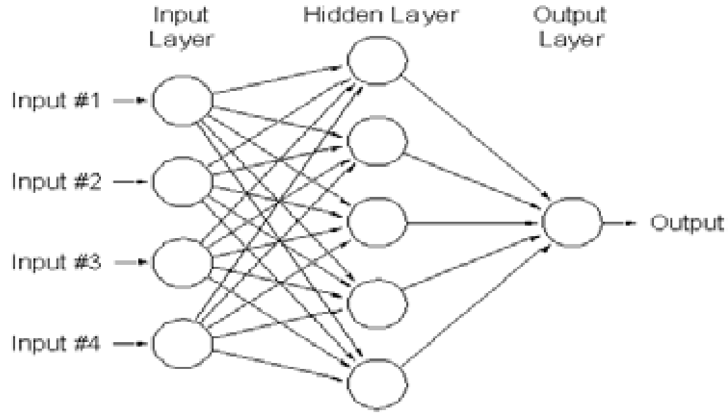
Here these are ANN mathematical models which mimicking biological neural networks where they consist of a group of connected which representing the neurons of the brain. It represented by a diagram of nodes in various layers with weighted connections between nodes in different layers. Where RBF network is an ANN that uses radial basis functions as activation functions where RBF networks typically have three layers that are input layer, hidden layer with a non-linear RBF activation function and an output layer with linear activation functions and the most popular form is given below:

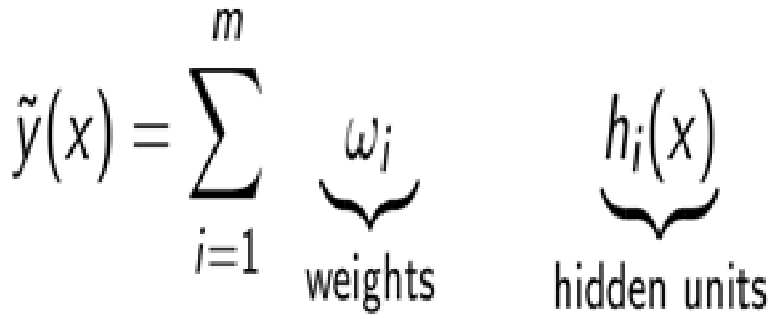
Where Ф is the activation function.
The proposed methodology or procedure for signature recognition and verification are as follows:
- Acquire the Signature images.
- Extract the various features.
- Use these features to train the system using ANN algorithm.

- Test the Signature image.

- Take decision as originals or forgeries

CONCLUSIONS

This proposed system is focused on online Signature Verification System using artificial neural network. Signatures are verified based on parameters extracted from the signature using various image processing techniques. This proposed system will gives utility of signature verification is shown. it helps in detecting the exact person and it provides more accuracy of verifying signatures for implementation of above, this paper uses Neural Networks for recognition and verification of signatures of individuals.

REFERENCES

- K. Han, and I.K. Sethi, “Handwritten Signature Retrieval and Identification”, Pattern Recognition 17, 1996, pp. 8390.
- S. Chen, and S. Srihari, “Use of Exterior Contour and Shape Features in Off-line Signature Verification”, 8th International Conference on Document Analysis and Recognition (ICDAR ’05), 2005, pp. 1280-1284.
- Özgündüz,T. Uentürk and M. E. Karslıgil, “Off line signature Verification and recognition by support vector machine”, Eusipco 2005, Antalya, Turkey 4 -8 September, 2005, , pp.113- 116.
- Wei Tian, Yizheng Qiao and Zhiqiang Ma, A New Scheme for Off-line Signature Verification Using DWT and Fuzzy Net, IEEE 8th ACISInternational Conference on Software Engineering, Artificial Intelligence, Networking, and Parallel/Distributed Computing, 2007, pp.30-35 [5] Luiz S. Oliveira, Edson Justino, and Robert Sabourin, Off-line Signature Verification Using Writer-Independent Approach, Proceedings of International Joint Conference on Neural Networks, Orlando, Florida, USA, August 12-17, IEEE 2007.
- Fernando Alonso-Fernandez, Julian Fierrez, Almudena Gilperez, Javier Galbally, Javier Ortega-Garcia, Robustness of Signature Verification Systems to Imitators With Increasing skills, IEEE 2009,pp. 728-732.
- Plamondon, “The Handwritten Signature as a Biometric Identifier: Psychophysical Model & System Design” IEEE Conference Publications, R.1995, Issue CP408, 23-27.
- Ali Karouni Bassam Daya, Samia Bahlak, Offline signature Recognition using neural networks approach, Procedia Computer Science 3, 2010, pp.155-161. [9] E.J.R. Justino, F. Bortolozzi, and R. Sabourin. “A comparison of SVM and HMM classifiers in the off-line signature verification”,Pattern Recognition Letters 26, 2005, pp. 1377-1385.
- Ms. Vibha Pandey Ms. Sanjivani Shantaiya. “ Signature Verification Using Morphological Features Based on
Artificial Neural Network”, 2012 pp. 288-292
- Suhail M. Odeh, Manal Khalil ,Off-line signature verification and recognition: Neural Network Approach,IEEE 2011,pp.34-38
- Vu Nguyen, Yumiko Kawazoey, Tetsushi
Wakabayashiy, Umapada Palz, and Michael Blumenstein, Performance Analysis of the Gradient Feature and the Modified Direction Feature for Off-line Signature Verification , the IEEE 12th International Conference on Frontiers in Handwriting Recognition, 2010,pp.303-307.
- Bradley Schafer, Serestina Viriri, An Off-Line Signature Verification System, IEEE International Conference on Signal and Image Processing Applications, 2009, pp. 95-100
- Michael Blumenstein, Graham Leedham, Vu Nguyen, Global Features for the Off-Line Signature Verification Problem, IEEE 10th International Conference on Document Analysis and Recognition, 2009, pp.1300-1304.

